**Exercise 1: Control Structures**

**Scenario 1:** The bank wants to apply a discount to loan interest rates for customers above 60 years old.

**Question:** Write a PL/SQL block that loops through all customers, checks their age, and if they are above 60, apply a 1% discount to their current loan interest rates.

**CODE SOLUTION**

BEGIN

FOR rec IN (SELECT * FROM Customers c JOIN Loans l ON c.CustomerID = l.CustomerID) LOOP

IF MONTHS_BETWEEN(SYSDATE, rec.DOB)/12 > 60 THEN

UPDATE Loans

SET InterestRate = InterestRate - 1

WHERE LoanID = rec.LoanID;

DBMS_OUTPUT.PUT_LINE(' Discount applied to interest rate for customer ID: ' || rec.CustomerID);

END IF;

END LOOP;

COMMIT;

END;

/

**OUTPUT**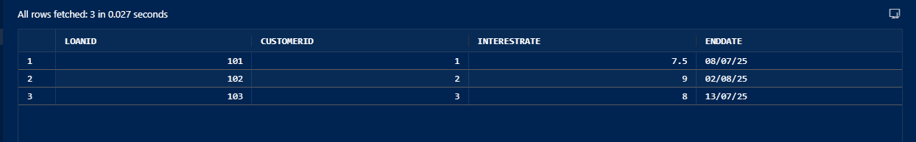

**Scenario 2:** A customer can be promoted to VIP status based on their balance.

**Question:** Write a PL/SQL block that iterates through all customers and sets a flag IsVIP to TRUE for those with a balance over $10,000.

**CODE SOLUTION**

BEGIN

  FOR r IN (SELECT * FROM Customers) LOOP

    IF r.Balance > 10000 THEN

      UPDATE Customers

      SET IsVIP = 'TRUE'

      WHERE CustomerID = r.CustomerID;

    END IF;

  END LOOP;

  COMMIT;

END;

/  
**OUTPUT**

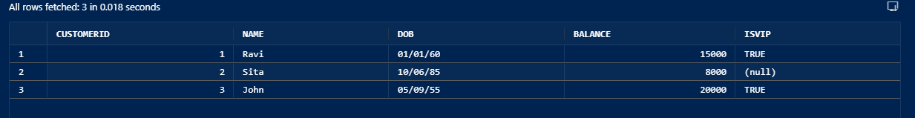

**Scenario 3:** The bank wants to send reminders to customers whose loans are due within the next 30 days.

**Question:** Write a PL/SQL block that fetches all loans due in the next 30 days and prints a reminder message for each customer.

**CODE SOLUTION**

BEGIN

FOR r IN (SELECT * FROM Loans WHERE EndDate BETWEEN SYSDATE AND SYSDATE + 30) LOOP

DBMS_OUTPUT.PUT_LINE('Reminder: Loan ' || r.LoanID || ' is due soon for Customer ' || r.CustomerID);

END LOOP;

END;

**OUTPUT**

